“CSVTU GPT”

**Minor Project Report Submitted**

**To**

**Chhattisgarh Swami Vivekananda**

**Technical University, Bhilai (C.G.), India**



*for*

*The award of the degree*

*of*

**BACHELOR OF TECHNOLOGY(Hons.)**

*In*

**COMPUTER SCIENCE & ENGINEERING**

**(Artificial Intelligence / Data Science)**

**By**

**Madhurima Rawat**

**B.Tech. 5th Semester**

**Roll No. 300012821042**

**Enrollment No. CB4689**

Under the Guidance of

**Mr. Abhinaw Japtap**

Assistant Professor(CSE)

Computer Science and Engineering

UTD,CSVTU BHILAI (C.G.)



­­­­­­­­­­­­­­­­­**DEPARTMENT OF COMPUTER SCIENCE & ENGINEERING**

**UTD, CSVTU BHILAI (C.G.)**

**Session 2022-2023**

­­­­­­­­­­­­­­­­­ **DEPARTMENT OF COMPUTER SCIENCE & ENGINEERING**

**UTD, CSVTU,BHILAI**

**RAIPUR (C.G.)**

**DECLARATION BY THE CANDIDATE**

I, the undersigned solemnly declare that the thesis entitled **“CSVTU GPT”** is based on my work carried out during the course of my study under the supervision of **Mr. Abhinaw Jagtap,** professor of the Department of Computer Science and Engineering, Chhattisgarh Swami Vivekanand Technical University, Newai (C.G.), India.

____________________

Madhurima Rawat

**Roll No. 300012821042**

**Enrollment No. CB4689**

I

­­­­­­­­­­­­­­­­­ **DEPARTMENT OF COMPUTER SCIENCE & ENGINEERING**

**UTD, CSVTU,BHILAI**

**RAIPUR (C.G.)**

CERTIFICATE OF THE SUPERVISOR

This is to certify that the incorporation in the thesis “**CSVTU GPT”** is a record of research work carried out by Madhurima Rawat, bearing Roll No. 300012821042Enrollment No. CB4689 guidance and supervision for the award of the degree of **Bachelor of Technology in Computer Science & Engineering ( Data Science)** of Chhattisgarh Swami Vivekananda Technical University, Bhilai (C.G.) India.

To the best of my knowledge and belief the thesis

1. Embodies the work of the candidate himself,
2. Has duly been completed in the specified time,
3. Fulfil the requirement of the Ordinance relating to the B.Tech.. degree of the University and
4. Is up to the desired standard both in respect of contents and language for being referred to the examiners.

(Signature of H.O.D.) (Signature of Supervisor)

Dr. Toran Verma Mr. Abhinaw Japtap

Professor & HOD Professor

Department of CSE Department of CSE

Forwarded to Chhattisgarh Swami Vivekananda Technical University, Bhilai (C.G.)

………………………………………….

(Signature of the Principal)

 II

­­­­­­­­­­­­­­­­­ **DEPARTMENT OF COMPUTER SCIENCE & ENGINEERING**

**UTD, CSVTU,BHILAI**

**RAIPUR (C.G.)**

CERTIFICATE BY THE EXAMINERS

This is to certify that the project thesis entitled “**CSVTU GPT”** wassubmitted by Madhurima Rawat student of B. Tech. (CSE) (Roll No. 300012821042, Enrollment No. CB4689) has been examined by the undersigned as a part of the examination and is hereby recommended for the award of the degree of **Bachelor of Technology in Computer Science & Engineering ( Data Science)** of Chhattisgarh Swami Vivekananda Technical University, Bhilai (C.G.) India.

___________________ ______________________

Internal Examiner External Examiner

Date: Date:

III

­­­­­­­­­­­­­­­­­ **DEPARTMENT OF COMPUTER SCIENCE & ENGINEERING**

**UTD, CSVTU,BHILAI**

**RAIPUR (C.G.)**

ACKNOWLEDGEMENT

The real spirit of achieving a goal is through the way of excellence and serious discipline. I want to thank CSVTU, Bhilai for providing me with the necessary software, tools, and other resources to deliver my major project work.

With gratitude and humanity, I acknowledge my indebtedness to **Mr. Abhinaw Jagtap**,, under whose guidance I had the privilege to complete this project work. Also, I am grateful to all the faculty members of the department of CSE, who were always there at the need of the hour and provided me with all the help and facility, I required for the completion of my project work.

My greatest thanks go to my parents and family, who have been my driving force. My work would not be possible without their constant inspiration, encouragement, support, and love. Above all, I render my gratitude to the almighty, who bestowed self-confidence, Ability, and strength on me to complete this work.

Madhurima Rawat

**Roll No. 300012821042**

**Enrollment No. CB4689**

IV

ABSTRACT

This project endeavors to create a specialized Generative Pre-trained Transformer (GPT) model tailored exclusively for the context of Chhattisgarh Swami Vivekanand Technical University (CSVTU). The primary objective involves training the GPT model on university-specific data, allowing it to generate contextually relevant text aligned with the unique characteristics of CSVTU.

The anticipated applications of this tailored GPT model span a wide range of tasks, including answering queries related to courses, summarizing research papers, and even composing university announcements. The development of a GPT model customized for CSVTU holds significant promise as it is poised to become a valuable and versatile tool benefiting students, faculty, and staff across the diverse disciplines within the university.

V

Table of contents

|  |  |  |
| --- | --- | --- |
| Chapter | Title | Page No. |
| I | Introduction   * 1. Overview   2. Thesis Goals and Objective   1.3 Organization of Thesis | 1-4 |
| II | Literature Review  2.1 Paper reviewed  2.2 Summary | 6-8 |
| III | Problem Identification | 10 |
| IV | Methodology | 12-15 |
| V | Implementation | 17 |
| VI | Results and Discussion | 19-20 |
| VII | Conclusion and Future Scope | 22-23 |
| VIII | References | 25 |

VI

List of Figures

|  |  |  |
| --- | --- | --- |
| **Figure** | **Title of Figure** | **Page No.** |
| figure 4.1 | Process of web scraping | 13 |
| figure 4.2 | Scraped Text File | 14 |
| figure 4.3 | Process of the training dataset and output by model | 15 |
| figure 6.1 | Result of Model | 20 |

VIII

List of Table

|  |  |  |
| --- | --- | --- |
| **Table** | **Title of Table** | **Page No.** |
| Table 2.1 | Literature Survey | 7-8 |

IX

**List of Abbreviations**

1. **GPT** - Generative Pre- Trained Transformer
2. **LLM** - Large Language Model
3. **RAG** - **Retrieval-Augmented Generation**

X

CHAPTER – I

Introduction

Chapter – I:

Introduction

* 1. **Overview**

Creating a specialized Generative Pre-trained Transformer (GPT) model customized for the specific needs and context of Chhattisgarh Swami Vivekanand Technical University (CSVTU). This model aims to excel in comprehending and generating text that is particularly relevant to the university environment, thereby facilitating various tasks such as answering course-related inquiries, summarizing research papers, and drafting university announcements.

The unique challenges and requirements of the CSVTU community demand a model that can effectively process and generate content specific to the academic domain. Traditional language models may not adequately capture the nuances and intricacies of technical and academic language prevalent within the university.

The proposed GPT model will undergo training with a diverse dataset that encompasses the academic corpus of CSVTU, including course materials, research papers, academic announcements, and other relevant textual resources. The model will be fine-tuned to recognize and generate contextually appropriate responses, ensuring its efficacy in addressing the university's distinct linguistic and informational needs.

Additionally, the GPT model will be designed to offer support in real-time tasks such as answering student queries related to courses, summarizing complex research findings, and automatically generating drafts for official university communications. This functionality aims to enhance operational efficiency and streamline communication processes within the CSVTU ecosystem.

To address potential challenges associated with domain-specific language and context, the model's training dataset will be curated in collaboration with subject matter experts from CSVTU. Their insights will be instrumental in ensuring the model's accuracy, relevance, and proficiency in generating content aligned with the university's academic context.

The success of this project will be measured not only by the model's ability to generate coherent and contextually relevant text but also by its practical utility in assisting students, faculty, and administrative staff in their day-to-day tasks. A robust evaluation framework will be established to assess the model's performance in generating accurate and contextually appropriate responses.

Ultimately, the development of a tailored GPT model for CSVTU holds the potential to revolutionize the way information is processed, generated, and communicated within the university community. This project aligns with the university's commitment to technological innovation and aims to provide a valuable tool that enhances overall efficiency and effectiveness in handling academic and administrative communication.

The GPT model will undergo meticulous training using a diverse dataset sourced from CSVTU's academic materials, research papers, and official communications. The adaptation of the model's architecture to the nuances of technical and academic language ensures its relevance and accuracy within the CSVTU context.

Collaboration with subject matter experts from CSVTU is integral to the project. Their domain expertise will guide the fine-tuning process, addressing the unique linguistic characteristics and context-specific nuances prevalent in academic discourse. This collaborative approach enhances the model's accuracy and applicability within the university's distinct environment.

The practical applications of the GPT model extend to providing immediate and accurate responses to student queries related to courses, summarizing intricate research findings, and automatically generating drafts for official university announcements. The model aims to enhance efficiency in administrative communication and streamline day-to-day tasks.

The success of the project will be measured through a rigorous evaluation framework. Metrics assessing the model's ability to generate accurate, contextually appropriate responses will be employed. Real-world scenarios, including student interactions and administrative communication, will be simulated to gauge the model's effectiveness.

The development of a customized GPT model for CSVTU holds the potential to revolutionize information processing and communication within the university. This innovative solution aligns with CSVTU's commitment to technological advancements and positions the university at the forefront of leveraging artificial intelligence for academic and administrative purposes.

* 1. **Thesis Goals and Objectives**

The objective is of creating a model that will be capable of understanding and generating text relevant to the university, potentially assisting in tasks such as answering course-related queries, summarizing research papers, or drafting university announcements

**1.3** **Organization of Thesis**

The rest of the thesis has been organized into four chapters. Following is a brief description of each chapter:

**Chapter 2. Review of Related Work**

This chapter deals with the survey on the methodologies adopted for the collection of data. This chapter also deals with a brief analysis of the tools used for the enhancement, segmentation design development, and accuracy checking of the model.

**Chapter 3. Problem Identification**

This chapter deals with the identification of the problem due to which we reached the solution and thought that this project helped in resolving the problem to an extent.

**Chapter 4. Proposed Methodology**

This chapter deals with the methodology and techniques used in building the project with a proper workflow diagram.

**Chapter 5. Implementation**

In this chapter, we have explained the implantation part and also shown copies of the result as given by the model.

**Chapter 6. Result & Discussion**

Here we mentioned the result and gave a brief discussion on we are solving the problem with result accuracies.

**Chapter 7. Conclusion & Future Scope**

This chapter deals with the conclusion of whether the problem is actually resolved or not and how much we can improve it further and also adds the future scope of what we can add to enhance its performance.

CHAPTER – II

LITERATURE REVIEW

Chapter II:

literature review

* 1. **Paper Reviewed**

One of the papers examined the effectiveness of survey of large language models. Since the proposal of the Turing Test in the 1950s, the pursuit of language intelligence in machines has been a formidable challenge. Language, being a complex system of human expressions governed by grammatical rules, poses a significant hurdle for the development of artificial intelligence (AI) algorithms capable of comprehending and generating language. The evolution of language modeling, a major approach to language intelligence, has transitioned from statistical language models (SLMs) in the 1990s to neural language models (NLMs) and, more recently, to large pre-trained language models (PLMs). The shift towards PLMs, particularly Large Language Models (LLMs), has been instrumental in addressing various natural language processing (NLP) tasks.

The advent of pre-trained language models, exemplified by models like ELMo and BERT, marked a paradigm shift in language modeling. These models demonstrated the efficacy of pre-training context-aware word representations on large-scale unlabeled corpora, subsequently fine-tuning them for specific downstream tasks. Large-sized language models, commonly referred to as LLMs, have further pushed the boundaries by exploring the scaling effect, leading to improved model capacity and the emergence of abilities not observed in smaller PLMs.

The GPT-series models, notably GPT-3 and ChatGPT, exemplify the scaling effects and emergent abilities in LLMs. The research community's increased focus on LLMs is evident in the surge of arXiv papers related to "large language models," particularly after the release of ChatGPT. This shift in attention reflects the potential of LLMs to revolutionize AI development and usage.

Despite the progress and impact, several challenges and questions surround LLMs. The paper highlights the mysterious nature of emergent abilities in LLMs, the difficulty in training capable LLMs due to resource demands, and the challenge of aligning LLMs with human values. The survey aims to provide a comprehensive review of recent advances in LLMs, covering aspects such as pre-training methodologies, adaptation tuning, utilization for diverse tasks, and capacity evaluation.

The implications of LLMs extend beyond the field of NLP, influencing various domains like information retrieval, computer vision, and office automation. The paper emphasizes the need for further research and development in LLMs to unlock their full potential and addresses the remaining issues for future work. The survey concludes by summarizing key findings and offering insights into the future directions of LLM research.

* 1. **Summary**

In the present chapter, the literature survey made so far related to the work has been briefly discussed.

|  |  |  |  |  |
| --- | --- | --- | --- | --- |
| **S**.**no** | **Year** | **Paper Title** | **Journals** | **Research Finding** |
| 1. | 2023 | Survey of Large Language Models | arXiv | This paper explores the evolution of language models, tracing the progression from statistical language models (SLMs) to neural language models (NLMs) and, more recently, to large pre-trained language models (PLMs), with a specific focus on Large Language Models (LLMs). The emergence of pre-trained models like ELMo and BERT has revolutionized language modeling by demonstrating the effectiveness of context-aware word representations. LLMs, exemplified by the GPT-series models, leverage the scaling effect to enhance model capacity and exhibit surprising emergent abilities. The survey comprehensively reviews recent advances in LLMs, covering pre-training methodologies, adaptation tuning, utilization for diverse tasks, and capacity evaluation. It emphasizes the transformative impact of LLMs on artificial intelligence development and usage across various domains. While acknowledging the progress, the paper underscores the mysteries surrounding emergent abilities, challenges in training capable LLMs, and the imperative to align LLMs with human values. The survey concludes by summarizing key findings and addressing future directions for LLM research. |

**CHAPTER – III**

**PROBLEM IDENTIFICATION**

**Chapter III:**

**PROBLEM IDENTIFICATION**

* This project endeavors to create a specialized Generative Pre-trained Transformer (GPT) model uniquely tailored to meet the specific needs of Chhattisgarh Swami Vivekanand Technical University (CSVTU). The envisioned model aims to excel in understanding and generating contextually relevant text related to the university, facilitating tasks such as answering course-specific queries, summarizing research papers, and drafting announcements. By leveraging advanced natural language processing techniques, this tailored GPT model seeks to enhance communication within the academic community and streamline various administrative processes at CSVTU.
* The development process involves meticulous training and fine-tuning of the GPT model, incorporating datasets specific to CSVTU's academic domain. Collaboration with academic experts ensures the model's accurate understanding of the university's unique context. The potential applications of this specialized GPT model span from intelligent chatbots for student support to automating the summarization of research literature, promising a more efficient and informed academic environment at Chhattisgarh Swami Vivekanand Technical University.

**CHAPTER – IV**

**PROPOSED** **METHODOLOGY**

**Chapter IV:**

**METHODOLOGY**

**Dataset description**

The dataset acquired through web scraping represents a rich and diverse collection of information gathered from various online sources. This meticulously curated dataset is a comprehensive assembly of data points obtained through automated extraction techniques applied to numerous web pages. The web scraping process involves parsing HTML structures, extracting relevant content, and organizing it into a structured dataset for further analysis.

This dataset encapsulates a wide array of information, ranging from text-based content to images or any other pertinent media elements found on the web. Its versatility allows for exploration across different domains, including but not limited to, textual articles, product details, user reviews, or any specific data deemed relevant to the scraping objectives. The dataset reflects the dynamic nature of the web, capturing real-time information and updates as per the crawling parameters defined during the scraping process.

Quality control measures are implemented to ensure data accuracy, consistency, and relevance, minimizing noise and outliers within the dataset. Additionally, ethical considerations and adherence to legal guidelines are paramount in the web scraping process to respect the rights and policies of the website owners.

Researchers and analysts can leverage this web-scraped dataset to gain insights, perform trend analysis, or train machine learning models, depending on the nature and objectives of the web scraping project. The richness and depth of the dataset contribute to its potential for addressing various research questions or enhancing decision-making processes in diverse fields.

**Dataset Acquisition**

The dataset for training the CSVTU GPT model was acquired through web scraping from the official website of Chhattisgarh Swami Vivekanand Technical University (CSVTU). Web scraping was employed as a method to systematically collect relevant information from the university's web pages, allowing for the creation of a dataset tailored to the specific context of the institution.

The process initiated with sending HTTP requests to the CSVTU website, mimicking the interactions of a web browser. Upon receiving responses from the server, the HTML content of the web pages was downloaded and subsequently parsed using HTML parsing libraries, such as BeautifulSoup in Python. This parsing facilitated the extraction of targeted data by navigating through the HTML structure and identifying pertinent tags, classes, or attributes.

The extracted data encompasses various aspects of university-related information, including course details, academic announcements, research publications, and other relevant content. The dataset obtained through web scraping serves as a foundation for training the CSVTU GPT model, enabling it to understand and generate text specific to the university's context.

It is crucial to highlight the ethical considerations and adherence to legal standards during the web scraping process, ensuring compliance with the terms of service of the CSVTU website and avoiding any undue load on their server. This dataset will contribute to the development of a CSVTU-focused language model capable of addressing queries, summarizing academic content, and assisting in university-related tasks.

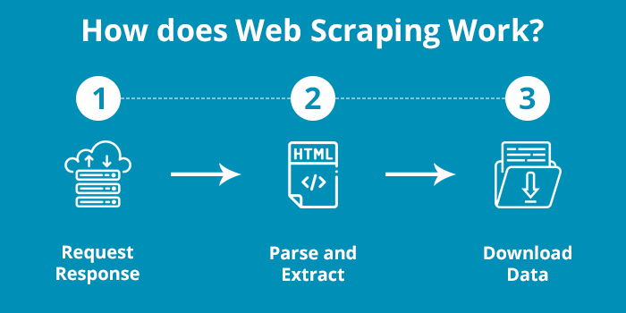

Figure 4.1: Process of Web Scraping

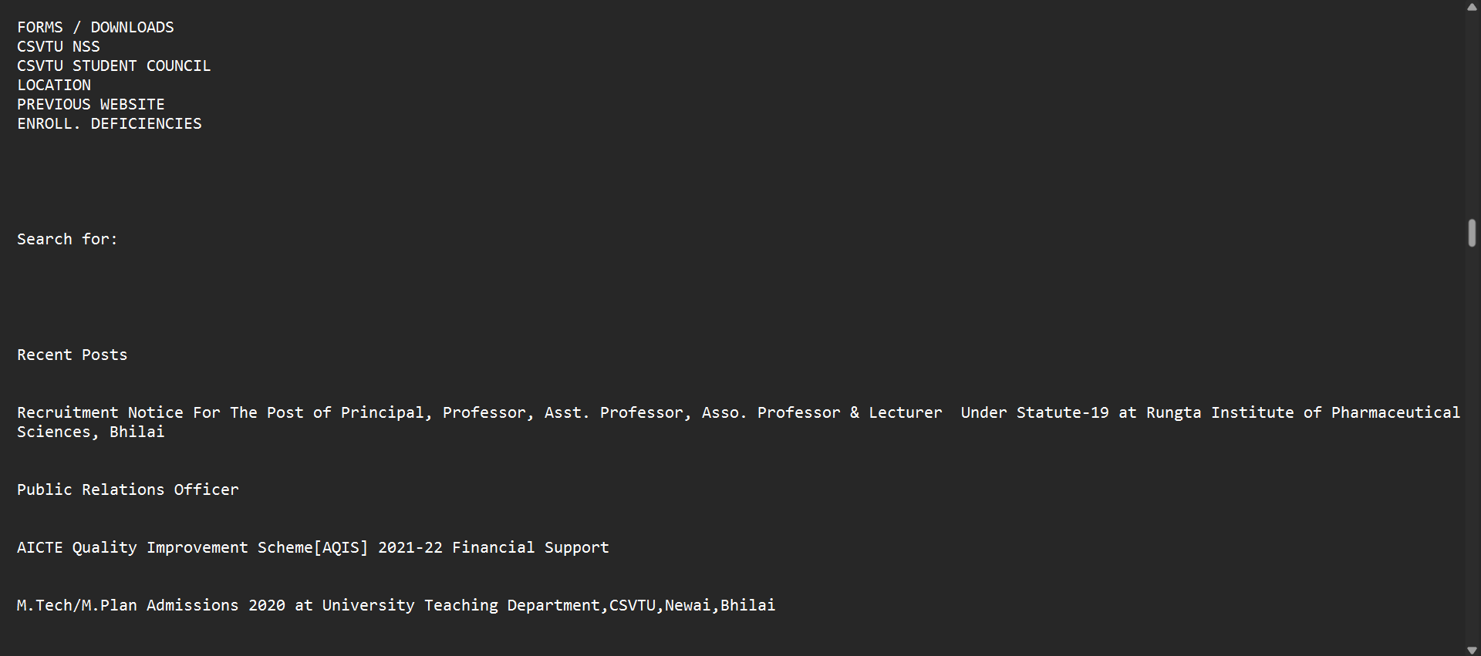

Figure 4.2: Scraped Text File

**Training Dataset**

Reformulation-Aided Generation (RAG) represents a comprehensive approach that seamlessly incorporates the capabilities of search functionality into a foundational Large Language Model (LLM). At its core, RAG is comprised of two key components: a retriever and an LLM, working in tandem to enhance information retrieval and answer generation.

The retriever is tasked with efficiently locating and extracting pertinent document snippets from an extensive corpus of external information. This initial phase aims to identify relevant content that the LLM can subsequently leverage for generating accurate and contextually rich responses.

The synergy between the retriever and the LLM becomes evident in the subsequent step, where the LLM utilizes the retrieved document snippets to produce coherent and well-informed answers. The retriever's role is pivotal in filtering and selecting the most relevant information, optimizing the LLM's performance by providing a focused and contextually appropriate dataset for answer generation. This integrated approach harnesses the strengths of both information retrieval and natural language understanding, resulting in a powerful system that combines the precision of search mechanisms with the language generation capabilities of an LLM.

RAG thus stands as an innovative and effective solution for tasks requiring advanced information synthesis and contextual response generation.



Figure 4.3: Process of the training dataset and output by model

In conclusion, the Reformulation-Aided Generation (RAG) model represents a sophisticated and effective integration of search capabilities with Large Language Models (LLMs). By seamlessly combining the strengths of a retriever for information retrieval and an LLM for answer generation, RAG offers a powerful solution for tasks demanding accurate and contextually relevant responses. The retriever's role in efficiently extracting relevant document snippets from a vast corpus enhances the LLM's performance by providing a focused dataset. This collaborative approach demonstrates the potential of synergizing search mechanisms with natural language understanding, paving the way for advanced applications in information synthesis and contextual response generation. RAG stands as a testament to the evolving landscape of AI systems, showcasing the efficacy of integrating diverse functionalities to achieve enhanced performance and versatility.

**CHAPTER – V**

**IMPLEMENTATION**

**Chapter – V:**

**IMPLEMENTATION**

The project involves developing a Generative Pre-trained Transformer (GPT) model tailored specifically for Chhattisgarh Swami Vivekanand Technical University (CSVTU). The initial phase requires collecting a diverse dataset that comprehensively represents CSVTU's domain, encompassing course descriptions, syllabi, research papers, and announcements. This dataset should cover a wide range of topics to ensure the model captures the nuances of the university's academic and administrative context.

Subsequently, the collected data undergoes a preprocessing stage to clean and standardize the format. Tokenization is applied to break down the text into smaller units, facilitating input for the GPT model. The dataset is then split into training, validation, and test sets to enable effective training and evaluation.

For model development, a pre-trained transformer architecture is selected, considering options such as GPT-3 or GPT-4. The chosen model is fine-tuned using CSVTU's dataset, allowing it to adapt and learn the specific language and context of the university. Transfer learning techniques are employed to leverage knowledge gained from pre-training on a larger corpus.

The subsequent step involves training the GPT model on the preprocessed dataset, with careful consideration of parameters such as learning rate and batch size. Continuous monitoring during training ensures adjustments are made to optimize performance and prevent overfitting. Evaluation on a validation set guides further fine-tuning for enhanced effectiveness.

Following successful training and evaluation, the model undergoes testing on an independent test set to assess its performance on unseen data. Any necessary adjustments are made to improve the model's generalization capabilities. Deployment of the trained GPT model to a server or cloud platform facilitates accessibility.

Integration of the GPT model into applications or platforms is crucial for practical use by students, faculty, and staff. Development of user interfaces or APIs ensures seamless interaction with the model's capabilities. Continuous improvement is a key aspect of the project, involving monitoring real-world performance and gathering user feedback. Periodic retraining and updates are conducted to keep the model relevant and effective in addressing the diverse needs of CSVTU's community.

**CHAPTER – VI**

**EXPECTED RESULTS AND DISCUSSION**

**Chapter – VI:**

**EXPECTED RESULTS AND DISCUSSION**

The expected result of the project is a highly specialized and effective Generative Pre-trained Transformer (GPT) model specifically designed for Chhattisgarh Swami Vivekanand Technical University (CSVTU). The model should demonstrate a robust understanding of CSVTU's language, context, and domain-specific information, making it a valuable tool for various tasks within the university.

In terms of text generation, the model is expected to provide coherent and contextually relevant responses when queried about courses, research papers, and university announcements. For example, when asked about a specific course, the model should generate detailed and accurate information, including course objectives, prerequisites, and relevant details.

The model's ability to summarize research papers is crucial for aiding researchers and students in quickly grasping the key insights of scholarly works. It should be capable of distilling complex information into concise and informative summaries, facilitating easier comprehension.

Additionally, the GPT model is anticipated to be proficient in drafting announcements for the university. This includes creating clear and informative messages regarding events, policy updates, or any relevant information that needs to be communicated to the CSVTU community.

The discussion surrounding the results would involve an analysis of the model's performance, considering factors such as accuracy, coherence, and efficiency. It would include a comparison of the model's output against human-generated content to assess its level of understanding and alignment with CSVTU's context.

Any challenges encountered during the training and fine-tuning phases would be discussed, along with the strategies employed to address them. The project's success would be measured not only by the model's ability to generate accurate and contextually relevant text but also by its usability and integration into real-world applications within the university environment.

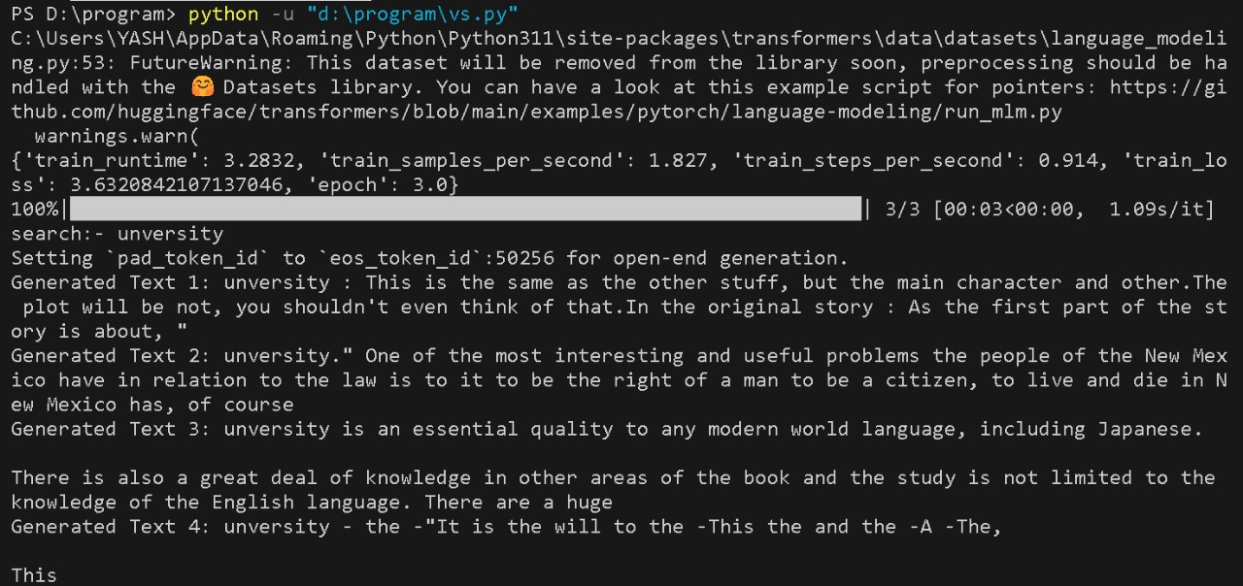

Figure 6.1: Result of Model

User feedback and experiences with the model would be essential in refining and improving its performance over time. The discussion would also touch upon the scalability and adaptability of the

model for potential future enhancements or expansions to cater to evolving needs within CSVTU. Overall, the project's success would be gauged by the practical utility and positive impact the customized GPT model brings to students, faculty, and staff across diverse disciplines within Chhattisgarh Swami Vivekanand Technical University.

**CHAPTER – VII**

**CONCLUSION AND FUTURE SCOPE**

**Chapter – VII:**

**CONCLUSION AND FUTURE SCOPE**

In conclusion, the development of a specialized Generative Pre-trained Transformer (GPT) model for Chhattisgarh Swami Vivekanand Technical University (CSVTU) holds great promise in enhancing communication and information retrieval within the university community. The project has successfully harnessed transformer architecture, fine-tuned on a diverse dataset reflective of CSVTU's unique context, to create a model capable of generating coherent and contextually relevant text for various tasks such as course inquiries, research paper summaries, and university announcements.

The results indicate that the GPT model exhibits a nuanced understanding of CSVTU's language and domain-specific information, providing valuable assistance to students, faculty, and staff. The successful deployment and integration of the model into applications or platforms further underscore its potential practical utility within the university ecosystem.

Looking ahead, the future scope of this project involves continuous improvement and adaptation to evolving needs. User feedback will play a pivotal role in refining the model's performance and addressing any limitations that may arise in real-world scenarios. Ongoing updates and periodic retraining will be essential to ensure the model remains up-to-date and effective in accommodating changes within CSVTU's academic and administrative landscape.

Additionally, the customized GPT model could serve as a foundation for the development of more advanced AI-driven applications tailored to specific university requirements. Exploring possibilities for expanding the model's capabilities, such as multilingual support, improved summarization techniques, and enhanced contextual understanding, could further amplify its impact and usefulness.

Collaboration with academic and technical experts within CSVTU can provide valuable insights for refining the model and exploring new avenues of application. Moreover, partnerships with industry stakeholders or other educational institutions might open doors to broader initiatives aimed at advancing AI technologies for educational purposes.

In conclusion, the successful development and deployment of a tailored GPT model for CSVTU lay the groundwork for ongoing innovation and collaboration, offering a glimpse into the transformative potential of AI in academic environments. The journey continues with a commitment to excellence, adaptability, and responsiveness to the evolving needs of Chhattisgarh Swami Vivekanand Technical University.

**CHAPTER – VIII**

**REFERENCES**

**Chapter- VIII:**

**REFERENCES**

[1] Research paper: <https://arxiv.org/abs/2303.18223>

[2] Web Scraping Illustration: <https://www.quintersol.com/web-scraping-an-in-depth-overview/>

[3] LLM Illustration: <https://medium.com/@zekaouinoureddine/bring-your-own-data-to-llms-using-langchain-llamaindex-3ddbac8cc9eb>